Instance creation on Digital ocean

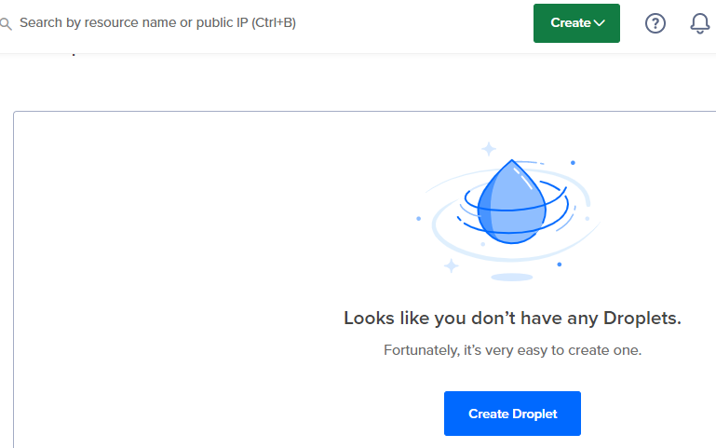

Select location “Bangalore”

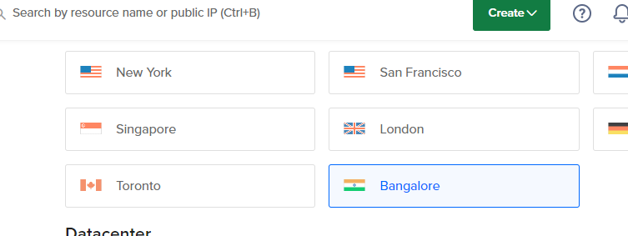

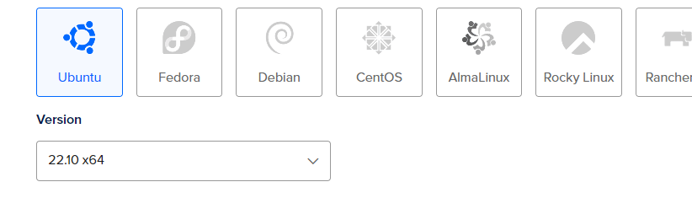

CPU and memory type

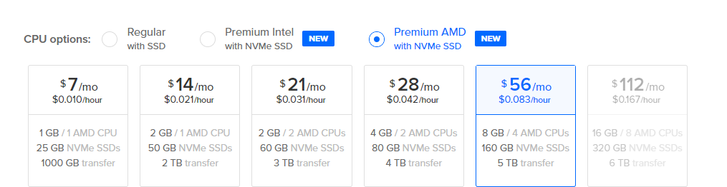

Check authentication type

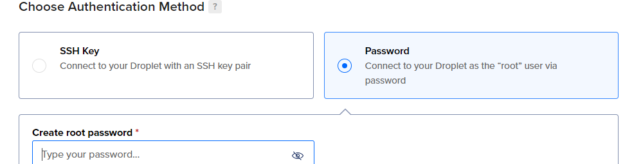

Provide the password:

Note down the ip address of machine

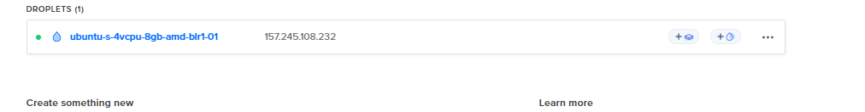

Open through putty